C - Decision Making
Decision making structures require that the programmer specify one or more conditions to be evaluated or tested by the program, along with a statement or statements to be executed if the condition is determined to be true, and optionally, other statements to be executed if the condition is determined to be false.
Following is the general from of a typical decision making structure found in most of the programming languages:
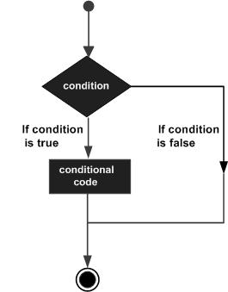
C programming language assumes any non-zero and non-null values as true and if it is either zero or null then it is assumed as false value.
C programming language provides following types of decision making statements. Click the following links to check their detail.
Statement | Description
if statement | An if statement consists of a boolean expression followed by one or more statements.
if...else statement | An if statement can be followed by an optional else statement, which executes when the boolean expression is false.
nested if statements | You can use one if or else if statement inside another if or else if statement(s).
switch statement | A switch statement allows a variable to be tested for equality against a list of values.
nested switch statements | You can use one swicth statement inside another switch statement(s).

C - if statement
An if statement consists of a boolean expression followed by one or more statements.

Syntax:
The syntax of an if statement in C programming language is:
if(boolean_expression)
{
/* statement(s) will execute if the boolean expression is true */
}
If the boolean expression evaluates to true then the block of code inside the if statement will be executed. If boolean expression evaluates to false then the first set of code after the end of the if statement(after the closing curly brace) will be executed.
C programming language assumes any non-zero and non-null values as true and if it is either zero or null then it is assumed as false value.

Flow Diagram:
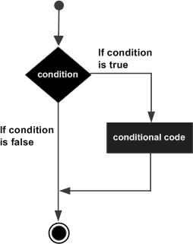

Example:
#include <stdio.h>

int main ()
{
/* local variable definition */
int a = 10;
/* check the boolean condition using if statement */
if( a < 20 )
{
/* if condition is true then print the following */
printf("a is less than 20\n" );
}
printf("value of a is : %d\n", a);
return 0;
}
When the above code is compiled and executed, it produces following result
a is less than 20;
value of a is : 10

C - if...else statement
An if statement can be followed by an optional else statement, which executes when the boolean expression is false.

Syntax:
The syntax of an if...else statement in C programming language is:
if(boolean_expression)
{
/* statement(s) will execute if the boolean expression is true */
}
else
{
/* statement(s) will execute if the boolean expression is false */
}
If the boolean expression evaluates to true then the if block of code will be executed otherwise else block of code will be executed.
C programming language assumes any non-zero and non-null values as true and if it is either zero or null then it is assumed as false value.

Flow Diagram:
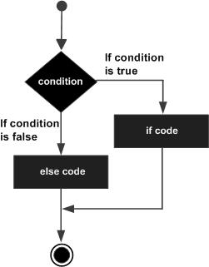

Example:
#include <stdio.h>
int main ()
{
/* local variable definition */
int a = 100;
/* check the boolean condition */
if( a < 20 )
{
/* if condition is true then print the following */
printf("a is less than 20\n" );
}
else
{
/* if condition is false then print the following */
printf("a is not less than 20\n" );
}
printf("value of a is : %d\n", a);

return 0;
}
When the above code is compiled and executed, it produces following result:
a is not less than 20;
value of a is : 100

The if...else if...else Statement
An if statement can be followed by an optional else if...else statement, which is very useful to test various conditions using single if...else if statement.
When using if , else if , else statements there are few points to keep in mind.
- An if can have zero or one else's and it must come after any else if's.
- An if can have zero to many else if's and they must come before the else.
- Once an else if succeeds, none of the remaining else if's or else's will be tested.

Syntax:
The syntax of an if...else if...else statement in C programming language is:
if(boolean_expression 1)
{
/* Executes when the boolean expression 1 is true */
}
else if( boolean_expression 2)
{
/* Executes when the boolean expression 2 is true */
}
else if( boolean_expression 3)
{
/* Executes when the boolean expression 3 is true */
}
else
{
/* executes when the none of the above condition is true */
}

Example:
#include <stdio.h>

int main ()
{
/* local variable definition */
int a = 100;
/* check the boolean condition */
if( a == 10 )
{
/* if condition is true then print the following */
printf("Value of a is 10\n" );
}
else if( a == 20 )
{
/* if else if condition is true */
printf("Value of a is 20\n" );
}
else if( a == 30 )
{
/* if else if condition is true */
printf("Value of a is 30\n" );
}
else
{
/* if none of the conditions is true */
printf("None of the values is matching\n" );
}
printf("Exact value of a is: %d\n", a );
return 0;
}
When the above code is compiled and executed, it produces following result:
None of the values is matching
Exact value of a is: 100

C - nested if statements
It is always legal in C programming to nest if-else statements, which means you can use one if or else if statement inside another if or else if statement(s).

Syntax:
The syntax for a nested if statement is as follows:
if( boolean_expression 1)
{
/* Executes when the boolean expression 1 is true */
if(boolean_expression 2)
{
/* Executes when the boolean expression 2 is true */
}
}
You can nest else if...else in the similar way as you have nested if statement.

Example:
#include <stdio.h>

int main ()
{
/* local variable definition */
int a = 100;
int b = 200;

/* check the boolean condition */
if( a == 100 )
{
/* if condition is true then check the following */
if( b == 200 )
{
/* if condition is true then print the following */
printf("Value of a is 100 and b is 200\n" );
}
}
printf("Exact value of a is : %d\n", a );
printf("Exact value of b is : %d\n", b );

return 0;
}
When the above code is compiled and executed, it produces following result:
Value of a is 100 and b is 200
Exact value of a is : 100
Exact value of b is : 200

C - switch statement
A switch statement allows a variable to be tested for equality against a list of values. Each value is called a case, and the variable being switched on is checked for each switch case.

Syntax:
The syntax for a switch statement in C programming language is as follows:
switch(expression){
case constant-expression :
statement(s);
break; /* optional */
case constant-expression :
statement(s);
break; /* optional */

/* you can have any number of case statements */
default : /* Optional */
statement(s);
}
The following rules apply to a switch statement:
- The expression used in a switch statement must have an integral or enumerated type, or be of a class type in which the class has a single conversion function to an integral or enumerated type.
- You can have any number of case statements within a switch. Each case is followed by the value to be compared to and a colon.
- The constant-expression for a case must be the same data type as the variable in the switch, and it must be a constant or a literal.
- When the variable being switched on is equal to a case, the statements following that case will execute until a break statement is reached.
- When a break statement is reached, the switch terminates, and the flow of control jumps to the next line following the switch statement.
- Not every case needs to contain a break. If no break appears, the flow of control will fall through to subsequent cases until a break is reached.
- A switch statement can have an optional default case, which must appear at the end of the switch. The default case can be used for performing a task when none of the cases is true. No break is needed in the default case.

Flow Diagram:
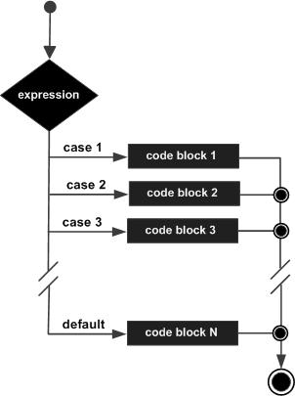

Example:
#include <stdio.h>

int main ()
{
/* local variable definition */
char grade = 'B';

switch(grade)
{
case 'A' :
printf("Excellent!\n" );
break;
case 'B' :
case 'C' :
printf("Well done\n" );
break;
case 'D' :
printf("You passed\n" );
break;
case 'F' :
printf("Better try again\n" );
break;
default :
printf("Invalid grade\n" );
}
printf("Your grade is %c\n", grade );

return 0;
}
When the above code is compiled and executed, it produces following result:
Well done
Your grade is B

C - nested switch statements
It is possible to have a switch as part of the statement sequence of an outer switch. Even if the case constants of the inner and outer switch contain common values, no conflicts will arise.

Syntax:
The syntax for a nested switch statement is as follows:
switch(ch1) {
case 'A':
printf("This A is part of outer switch" );
switch(ch2) {
case 'A':
printf("This A is part of inner switch" );
break;
case 'B': /* case code */
}
break;
case 'B': /* case code */
}

Example:
#include <stdio.h>

int main ()
{
/* local variable definition */
int a = 100;
int b = 200;

switch(a) {
case 100:
printf("This is part of outer switch\n", a );
switch(b) {
case 200:
printf("This is part of inner switch\n", a );
}
}
printf("Exact value of a is : %d\n", a );
printf("Exact value of b is : %d\n", b );

return 0;
}
When the above code is compiled and executed, it produces following result:
This is part of outer switch
This is part of inner switch
Exact value of a is : 100
Exact value of b is : 200

The ? : Operator:
We have covered conditional operator ? : in previous chapter which can be used to replace if...else statements. It has the following general form:
Exp1 ? Exp2 : Exp3;
Where Exp1, Exp2, and Exp3 are expressions. Notice the use and placement of the colon.
The value of a ? expression is determined like this: Exp1 is evaluated. If it is true, then Exp2 is evaluated and becomes the value of the entire ? expression. If Exp1 is false, then Exp3 is evaluated and its value becomes the value of the expression.

C - Loops
There may be a situation when you need to execute a block of code several number of times. In general statements are executed sequentially: The first statement in a function is executed first, followed by the second, and so on.
Programming languages provide various control structures that allow for more complicated execution paths.
A loop statement allows us to execute a statement or group of statements multiple times and following is the general from of a loop statement in most of the programming languages:
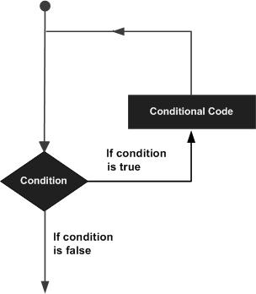
C programming language provides following types of loop to handle looping requirements. Click the following links to check their detail.
Loop Type | Description
while loop | Repeats a statement or group of statements until a given condition is true. It tests the condition before executing the loop body.
for loop | Execute a sequence of statements multiple times and abbreviates the code that manages the loop variable.
do...while loop | Like a while statement, except that it tests the condition at the end of the loop body
nested loops | You can use one or more loop inside any another while, for or do..while loop.

while loop in C
while loop statement in C programming language repeatedly executes a target statement as long as a given condition is true.

Syntax:
The syntax of a while loop in C programming language is:
while(condition)
{
statement(s);
}
Here statement(s) may be a single statement or a block of statements. The condition may be any expression, and true is any nonzero value. The loop iterates while the condition is true.
When the condition becomes false, program control passes to the line immediately following the loop.

Flow Diagram:
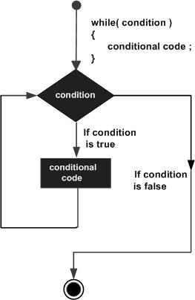
Here key point of the while loop is that the loop might not ever run. When the condition is tested and the result is false, the loop body will be skipped and the first statement after the while loop will be executed.

Example:
#include <stdio.h>

int main ()
{
/* local variable definition */
int a = 10;

/* while loop execution */
while( a < 20 )
{
printf("value of a: %d\n", a);
a++;
}

return 0;
}
When the above code is compiled and executed, it produces following result:
value of a: 10
value of a: 11
value of a: 12
value of a: 13
value of a: 14
value of a: 15
value of a: 16
value of a: 17
value of a: 18
value of a: 19

for loop in C
A for loop is a repetition control structure that allows you to efficiently write a loop that needs to execute a specific number of times.

Syntax:
The syntax of a for loop in C programming language is:
for ( init; condition; increment )
{
statement(s);
}
Here is the flow of control in a for loop:
- The init step is executed first, and only once. This step allows you to declare and initialize any loop control variables. You are not required to put a statement here, as long as a semicolon appears.
- Next, the condition is evaluated. If it is true, the body of the loop is executed. If it is false, the body of the loop does not execute and flow of control jumps to the next statement just after the for loop.
- After the body of the for loop executes, the flow of control jumps back up to the increment statement. This statement allows you to update any loop control variables. This statement can be left blank, as long as a semicolon appears after the condition.
- The condition is now evaluated again. If it is true, the loop executes and the process repeats itself (body of loop, then increment step, and then again condition). After the condition becomes false, the for loop terminates.

Flow Diagram:
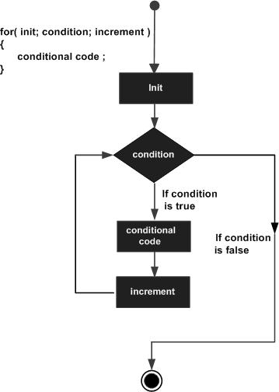

Example:
#include <stdio.h>

int main ()
{
/* for loop execution */
for( int a = 10; a < 20; a = a + 1 )
{
printf("value of a: %d\n", a);
}

return 0;
}
When the above code is compiled and executed, it produces following result:
value of a: 10
value of a: 11
value of a: 12
value of a: 13
value of a: 14
value of a: 15
value of a: 16
value of a: 17
value of a: 18
value of a: 19

do...while loop in C
Unlike for and while loops, which test the loop condition at the top of the loop, the do...while loop in C programming language checks its condition at the bottom of the loop.
A do...while loop is similar to a while loop, except that a do...while loop is guaranteed to execute at least one time.

Syntax:
The syntax of a do...while loop in C programming language is:
do
{
statement(s);

}while( condition );
Notice that the conditional expression appears at the end of the loop, so the statement(s) in the loop execute once before the condition is tested.
If the condition is true, the flow of control jumps back up to do, and the statement(s) in the loop execute again. This process repeats until the given condition becomes false.

Flow Diagram:
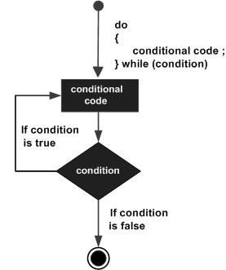

Example:
#include <stdio.h>

int main ()
{
/* local variable definition */
int a = 10;

/* do loop execution */
do
{
printf("value of a: %d\n", a);
a = a + 1;
}while( a < 20 );

return 0;
}
When the above code is compiled and executed, it produces following result:
value of a: 10
value of a: 11
value of a: 12
value of a: 13
value of a: 14
value of a: 15
value of a: 16
value of a: 17
value of a: 18
value of a: 19

nested loops in C
C programming language allows to use one loop inside another loop. Following section shows few examples to illustrate the concept.

Syntax:
The syntax for a nested for loop statement in C is as follows:
for ( init; condition; increment )
{
for ( init; condition; increment )
{
statement(s);
}
statement(s);
}
The syntax for a nested while loop statement in C programming language is as follows:
while(condition)
{
while(condition)
{
statement(s);
}
statement(s);
}
The syntax for a nested do...while loop statement in C programming language is as follows:
do
{
statement(s);
do
{
statement(s);
}while( condition );

}while( condition );
A final note on loop nesting is that you can put any type of loop inside of any other type of loop. For example a for loop can be inside a while loop or vice versa.

Example:
The following program uses a nested for loop to find the prime numbers from 2 to 100:
#include <stdio.h>

int main ()
{
/* local variable definition */
int i, j;

for(i=2; i<100; i++) {
for(j=2; j <= (i/j); j++)
if(!(i%j)) break; // if factor found, not prime
if(j > (i/j)) printf("%d is prime\n", i);
}

return 0;
}
When the above code is compiled and executed, it produces following result:
2 is prime 3 is prime 5 is prime 7 is prime 11 is prime 13 is prime 17 is prime 19 is prime 23 is prime 29 is prime 31 is prime 37 is prime 41 is prime 43 is prime 47 is prime 53 is prime 59 is prime 61 is prime 67 is prime 71 is prime 73 is prime 79 is prime 83 is prime 89 is prime 97 is prime

Loop Control Statements:
Loop control statements change execution from its normal sequence. When execution leaves a scope, all automatic objects that were created in that scope are destroyed.
C supports the following control statements. Click the following links to check their detail.
Control Statement | Description
break statement | Terminates the loop or switch statement and transfers execution to the statement immediately following the loop or switch.
continue statement | Causes the loop to skip the remainder of its body and immediately retest its condition prior to reiterating.
goto statement | Transfers control to the labeled statement. Though it is not advised to use goto statement in your program.

break statement in C

The break statement in C programming language has following two usage:
- When the break statement is encountered inside a loop, the loop is immediately terminated and program control resumes at the next statement following the loop.
- It can be used to terminate a case in the switch statement (covered in the next chapter).
If you are using nested loops ( ie. one loop inside another loop), the break statement will stop the execution of the innermost loop and start executing the next line of code after the block.

Syntax:
The syntax for a break statement in C is as follows:
break;

Flow Diagram:
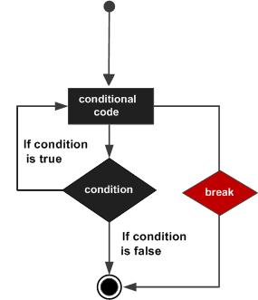

Example:
#include <stdio.h>

int main ()
{
/* local variable definition */
int a = 10;

/* while loop execution */
while( a < 20 )
{
printf("value of a: %d\n", a);
a++;
if( a > 15)
{
/* terminate the loop using break statement */
break;
}
}

return 0;
}
When the above code is compiled and executed, it produces following result:
value of a: 10
value of a: 11
value of a: 12
value of a: 13
value of a: 14
value of a: 15

continue statement in C
The continue statement in C programming language works somewhat like the break statement. Instead of forcing termination, however, continue forces the next iteration of the loop to take place, skipping any code in between.
For the for loop, continue statement causes the conditional test and increment portions of the loop to execute. For the while and do...while loops, continue statement causes the program control passes to the conditional tests.

Syntax:
The syntax for a continue statement in C is as follows:
continue;

Flow Diagram:
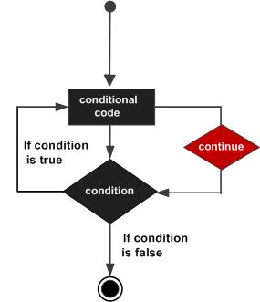

Example:
#include <stdio.h>

int main ()
{
/* local variable definition */
int a = 10;

/* do loop execution */
do
{
if( a == 15)
{
/* skip the iteration */
a = a + 1;
continue;
}
printf("value of a: %d\n", a);
a++;

}while( a < 20 );

return 0;
}
When the above code is compiled and executed, it produces following result:
value of a: 10
value of a: 11
value of a: 12
value of a: 13
value of a: 14
value of a: 16
value of a: 17
value of a: 18
value of a: 19

goto statement in C
A goto statement in C programming language provides an unconditional jump from the goto to a labeled statement in the same function.
NOTE: Use of goto statement is highly discouraged in any programming language because it makes difficult to trace the control flow of a program, making the program hard to understand and hard to modify. Any program that uses a goto can be rewritten so that it doesn't need the goto.

Syntax:
The syntax for a goto statement in C is as follows:
goto label;
..
.
label: statement;
Here label can be any plain text except C keyword and it can be set anywhere in the C program above or below to goto statement.

Flow Diagram:
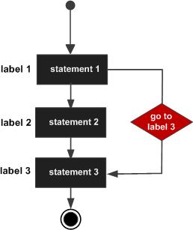

Example:
#include <stdio.h>

int main ()
{
/* local variable definition */
int a = 10;

/* do loop execution */
LOOP:do
{
if( a == 15)
{
/* skip the iteration */
a = a + 1;
goto LOOP;
}
printf("value of a: %d\n", a);
a++;

}while( a < 20 );

return 0;
}
When the above code is compiled and executed, it produces following result:
value of a: 10
value of a: 11
value of a: 12
value of a: 13
value of a: 14
value of a: 16
value of a: 17
value of a: 18
value of a: 19

The Infinite Loop:
A loop becomes infinite loop if a condition never becomes false. The for loop is traditionally used for this purpose. Since none of the three expressions that form the for loop are required, you can make an endless loop by leaving the conditional expression empty.
#include <stdio.h>

int main ()
{

for( ; ; )
{
printf("This loop will run forever.\n");
}

return 0;
}
When the conditional expression is absent, it is assumed to be true. You may have an initialization and increment expression, but C programmers more commonly use the for(;;) construct to signify an infinite loop.
NOTE: You can terminate an infinite loop by pressing Ctrl + C keys

